UNIT-V

SYSTEM MODELING
Per-unit system
In the power systems analysis field of electrical engineering, a per-unit system is the expression of system quantities as fractions of a defined base unit quantity. Calculations are simplified because quantities expressed as per-unit do not change when they are referred from one side of a transformer to the other
Definition: The per unit value of any quantity is defined as the ratio of actual value in any unit and the base or reference value in the same unit. Any quantity is converted into per unit quantity by dividing the numeral value by the chosen base value of the same dimension.The per unit value is dimensionless.
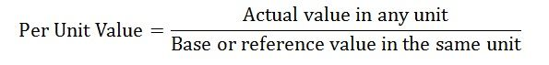The base values can be selected arbitrarily. It is usual to assume the base values as given below
- Base voltage = rated voltage of the machine
- Base current = rated current of the machine
- Base impedance = base voltage /base current
- Base power = base voltage x base current
Firstly the value of base power and the base voltage is selected, and their choice automatically fixes the other base values.
As
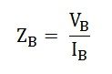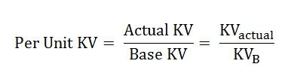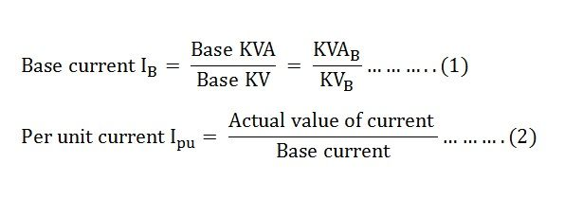Putting the value of base current from the equation (1) in equation (2) we get
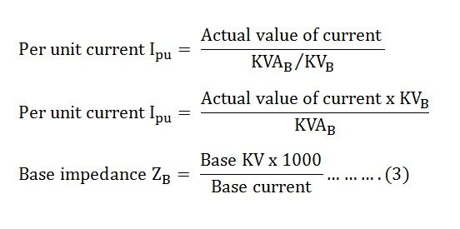Putting the value of base current from the equation (1) in the equation (3) we get
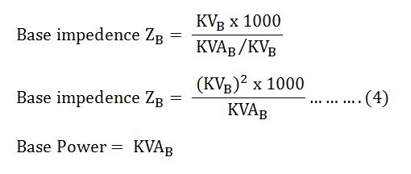
Now,
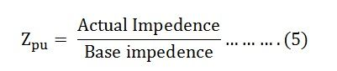
Putting the value of base impedance from the equation (4) in the equation (5) we will get the value of impedance per unit
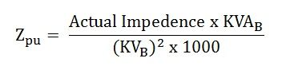

Advantages of Per Unit System
There are mainly two advantages of using the Per Unit System.
- The parameters of the rotating electrical machines and the transformer lies roughly in the same range of numerical values irrespective of their ratings if expressed in per unit system of their ratings.
- It relieves the analyst of the need to refer circuit quantities to one or other side of the transformer, making the calculations easy.
per unit (pu) system disadvantages:
- For transmission lines, its value of impedance and admittances in physical units (eg: ohms/km) that are of same magnitude regardless of voltage level or MVA rating
- Equivalent circuits of the components are modified, making them somewhat more abstract. Sometimes phase shifts that are clearly presented in the un scaled circuits varnish in per-unit system
Taking the example of a transformer having the resistance in the per unit as R_{pu} ohm and the reactance as X_{pu} in ohm with referred to primary then per unit values will be
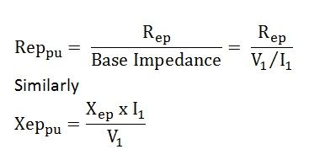
Where Rep and Xep is resistance and reactance referred to primary and pu means in per unit system.
The resistance and leakage reactance referred to primary in per unit are same as referred to secondary in per unit system because Where Res and Xes are the equivalent resistance and reactance referred to secondary

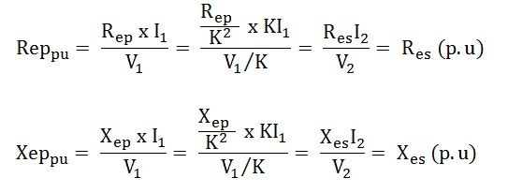
There from the above two equations, it is clear that the need for an ideal transformer is eliminated because the per unit impedance is same for the equivalent circuit of the transformer whether computed from the primary or secondary as long as the voltage bases on the two sides are selected in the ratio of transformation.

Single Line Diagram of Power System
Definition: Single line diagram is the representation of a power system using the simple symbol for each component. The single line diagram of a power system is the network which shows the main connections and arrangement of the system components along with their data (such as output rating, voltage, resistance and reactance, etc.).
It is not necessary to show all the components of the system on a single line diagram, e.g., circuit breaker need not be shown in the load flow study but are the must for a protection study. In the single line diagram, the system component is usually drawn in the form of their symbols. Generator and transformer connections, star, delta and neutral earthing are indicated by symbols drawn by the side of the representation of these elements.
Circuit breakers are represented by rectangular blocks. The figure shown below represents the single line diagram of a typical power system. It is difficult to draw the line diagram of the few components. So for simplification, the impedance diagram is used for representing the power system components.

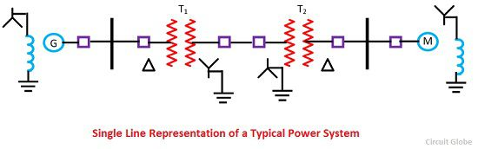
Fig 5.1 Single line diagram representation of a typical power system

MATHEMATICAL MODELLING of SYNCHRONOUS MACHINE ,TRANSFORMER & TRANSMISSION LINE:

Impedance Diagram for the Power System:
In impedance diagram, each component is represented by its equivalent circuit, e.g., the synchronous generator at the generating station by a voltage source in series with the resistance and reactance, the transformer by a nominal ∏-equivalent circuit. The load is assumed to be passive and are represented by a resistive and inductive reactance in the series. Neutral earthing impedance does not appear in the diagram as the balanced condition is assumed.
The diagram shown below is the balanced 3-phase diagram. It is also called positive sequence diagram. Three separate diagrams are also used for representing the positive, negative and zero sequence networks. The three separate impedance diagrams are used in the short circuit for the studies of unsymmetrical fault.

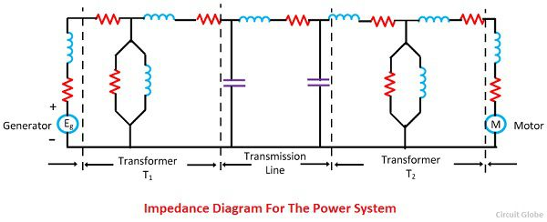
Fig 5.2 Impedance diagram of the power system
The impedance diagram can further be simplified by making certain assumptions and reduced to simplified reactance. Reactance diagram is drawn by neglecting the effective resistance of generator armature, transformer winding resistance, transmission line resistance line charging and the magnetising circuit of transformers. Reactance diagram of the power system is shown below.

Reactance Diagram for the Power System
The reactance diagram gives an accurate result for many power system studies, such as short-circuit studies, etc. The winding resistance, including the line resistance, are quite small in comparison with leakage reactance and shunt path which includes line charging and transformer magnetising circuit provide a very high parallel impedance with fault.
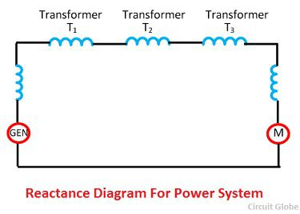
Fig 5.3 Reactance diagram of the power system
It is considered that if the resistance is less than one-third of the reactance, and resistance is ignored, then the error introduced will be not more than 5 %. If the resistance and reactance ignored errors up to 12% may be introduced. The errors mean their calculation gives a higher value than the actual value

